**Trello**

|  |  |  |  |  |  |
| --- | --- | --- | --- | --- | --- |
|  |  |  |  |  |  |

**Note:** Only App with a loading screen (Shot #2). Also has friendly welcoming slide notes (#3-#4) on login page. Also like the translucent tutorial screen once logged in and the tutorial board (#6). Color Palette: Blue, White, grey and dark blue. Smart watch integration.

**Pro:** Tutorials, Smartwatch friendly.

**Asana**

|  |  |  |  |  |
| --- | --- | --- | --- | --- |
|  |  |  |  |  |

**Note:** Most modern. Like the gradient and makes it very clean and simple looking. No loading screen. Logged in screen also uses asana logo as loading icon. Color Palette: Login Screen: Red/Orange gradient + White Main: White, Blue, grey, Asana Orange.

**Pro:** Modern and sleek

**Con:** Sends email to complete sign up

**SmartSheet**

|  |  |
| --- | --- |
|  |  |

**Note:** Very outdated looking. Not visually appealing in comparison. Similar color scheme as others. Many lower end task apps look similar/ as outdated to this one.

**Con:** Outdated

**Wunderlist**

|  |  |  |
| --- | --- | --- |
|  |  |  |

**Note:** Very cool slide notes on login page (each slide transitions to the next). Has multiple choices to make an account. Different color scheme from the rest: Aesthetic yellow based picture in the background, forest green tabs and white. Very simple app, just tap and add task. Smart watch integration.

**Pro:** Most simple and intuitive. Smartwatch friendly.

**Con:** Simplicity takes away features.

# 

**Note:** I believe our splash screen should be similar to trellos with the neat logo come up to the middle, possibly pulsate, and then slide up to the login screen or main menu depending on the user. I do like the slide tutorials on the login screen as it familiarizes the user before they even log in. For the sign up, I believe Asana clean screen (#3) would look very nice with our own color palette as well as a shake effect with the wrong credentials are entered. I also like Asanas main menu over trellos as it provides a user icon (top right), a loading icon when swiped down and the and looks more modern. The trello board tutorial could also be a nice addition for any users who need additional help getting started.

**Additional Notes:** If time allows the fb/google logins should be integrated, as well as featuring task in the smartphones calendar, google calendar as well as smartwatch integration. Smartwatch integration is offered by less than half the total task apps.

**Color Palettes:** Considering that our logo is blue as well as most task helpers using a blue color scheme these are a few scheme I believe may go well with our product.

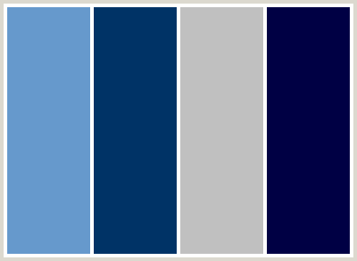

Nice blues with a grey balance and white of course. May be too dark overall though.

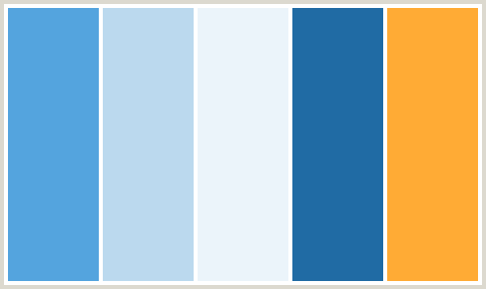

More bright with lighter options as well as a pop color (which could match the penguin's beak)

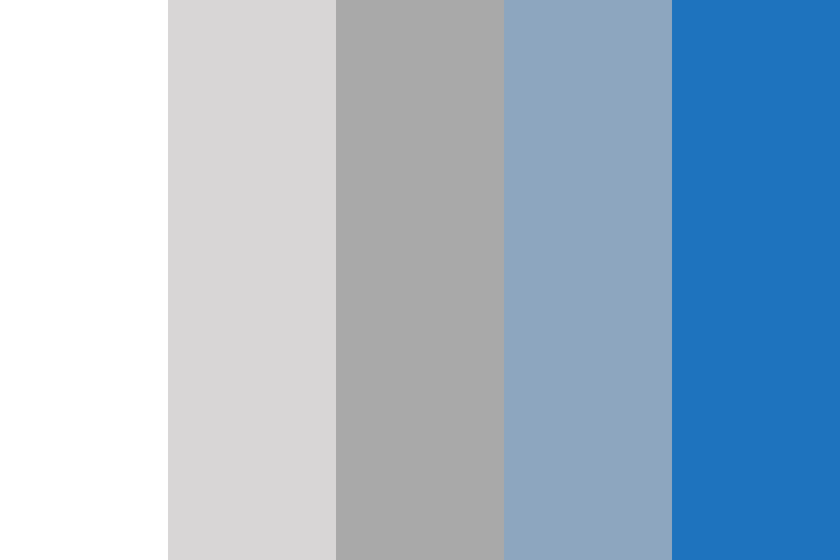

More of a washed down but a non-overwhelming/cool color scheme

**Cliffs:** Should look at Asana for modern inspiration as it's the most visually appealing off the bat. Trello has some good tutorial points to bring into the product.